Figure It Out Game
Instructions
Divide the group in two teams. The teams will do the task one after the other
Time: 20 minutes, 10 minutes each team
Technical requirements: flipchart, flipchart paper, dark marker pen
Team 1
Select one person responsible for drawing. Provide them with flipchart, paper and black marker pen.
Present the drawing (table 1) to the the team. The person who will do the drawing can not see it.
The task of the team is to give as many instructions to the drawer as possible in order for him/her/them to copy the drawing from table 1. Instructions may include shapes, sizes, relations in space etc.
Attention: it is not possible to repeat the instructions. The person who is drawing the figures can not ask questions.

Team 2
Select one person responsible for drawing. Provide them with flipchart, paper and black marker pen.
Present the drawing (table 2) to the the team. The person who will do the drawing can not see it.
The task of the team is to give as many instructions to the drawer as possible in order for him/her/them to copy the drawing from table 1. Instructions may include shapes, sizes, relations in space etc.
Attention: The person who is drawing the figures can ask as many questions as he/she/they wish.

Once the drawings are doneboth groups verify if the figures are replicated correctly.

Discuss what the communication was like. What helped and what disturbed the process.
Please underline the importance of verbal communication and active listening.

Source: www.katarzynapluska.pl

Table 1

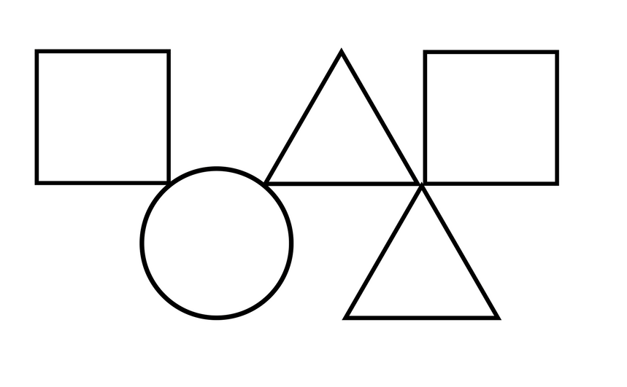

Table 2

