MODULE 4 – CONFLICT SOLVING

M4.WS10 - SELF KNOWLEDGE: GET TO KNOW YOURSELF BETTER

16 personalities

- description of who you are and why you do things the way you do; how to understand others
- you’ll learn what really drives, inspires, and worries different personality types, helping you build more meaningful relationships
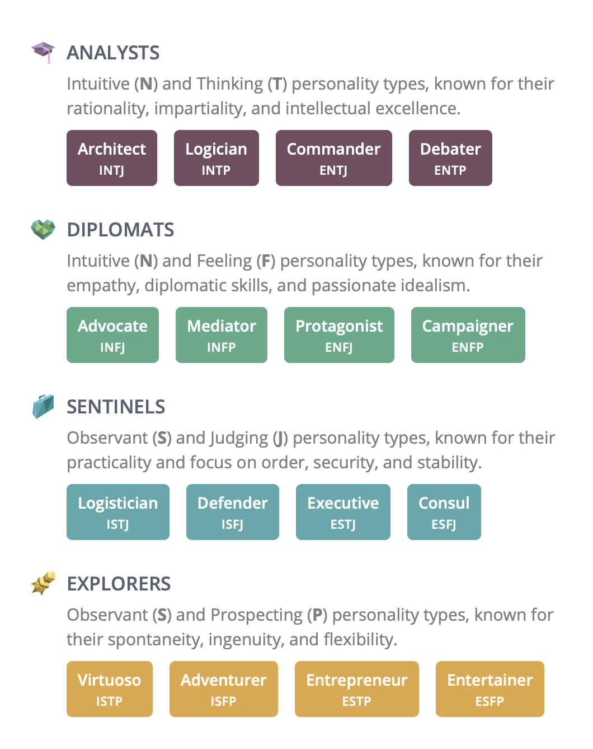
To know yourself better reduces the risk of negative conflict.

Activity: Take the test and share your personality type and your feelings about it with each other. Take the test here: https://www.16personalities.com/free-personality-test You can explore each personality type in detail on this webpage.
