MODULE 4 – CONFLICT SOLVING

M4.WS11 - A NEW TEAM MEMBER AS A POTENTIAL CAUSE OF TENSION AND CONFLICT

A new team member can be a source of conflict in the workplace. There can be a lack of integration into the work team, for example due to unclear organizational culture, imprecise rules, different personality types and diversity, and poor leadership (a new member does not know what to do and what exactly he or she is responsible for; inability of leadership to use qualities and talents).

There are several ways to prevent these conflicts:
- It is important to know what type of person we are looking for in the organization and what role they should play in terms of team roles before hiring a team member.
- In this context, it is good to know, for example, Belbin Team Roles, which we will get acquainted with. You can read about them below in the text.
- It is good to try to quickly identify the strengths and weaknesses and use the talent of a new colleague.
- Trust your new colleagues and afford them the freedom to work with a great deal of autonomy.
- 5 principles of employee empowerment to empower employees; management must transfer some decision-making authority – this shows employees that management has faith in them.

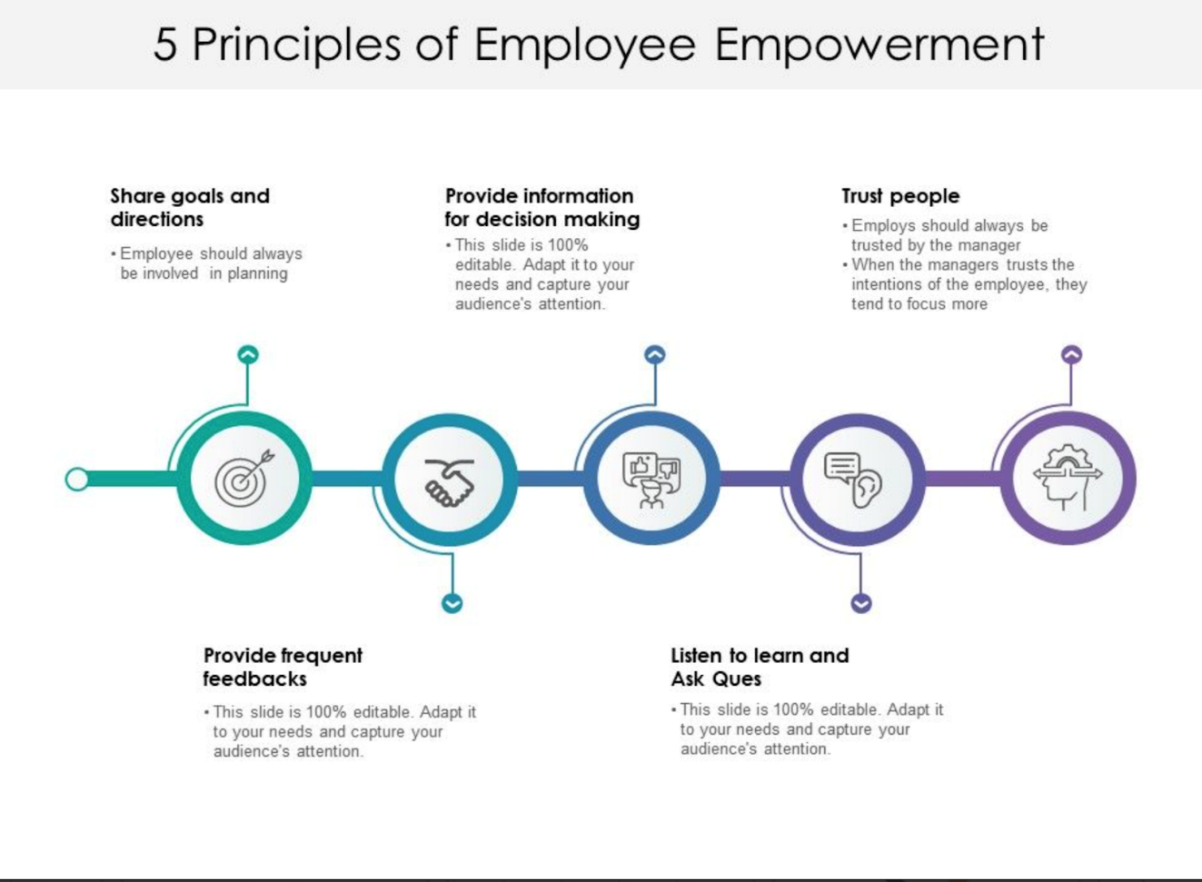

- Good communication
- Power gap – the gap that exists between a leader and their staff

- There must also be clearly defined values that make up the culture of your organization.

Activity - Do you know the main values of your organization? Share those values with each other.

- Have a manual of formal rules and at the same time introduce a new member to the system of informal rules. To do this, it is necessary to have the boundaries of your organization's culture set.

How to Integrate a New Team Member to Your Group (Joe Issid)
Integrating new employees into an already well-functioning team can be tricky and can introduce a great deal of risk. There are some proactive measures you can implement to improve how you integrate new members to the team.

Team interviews
- less formal "interviews" between candidates and members of the team at large can be an extremely effective way of gaining consensus around a candidate who would fit in well (it is very important for everyone on the team to have a say in recruiting new team members)

Formal process
- a well-defined onboarding process for new employees
- can include: formal introductions to key members of the existing staff; an introductory course on company policies and procedures; a formal meeting with the new manager to outline responsibilities and expectations; a formal introduction with all new team members; a full tour of the office facilities etc.

Social introduction
- taking the team out for lunch with the new employee as a way of welcoming them to the team
- this relaxes the new employee and allows them to see their new co-workers in a more friendly and multi-dimensional way

Empowerment
- trust your colleagues and afford them the freedom to work with a great deal of autonomy (it applies to new employees as well)
- enabling new team members to do their jobs from day one has shown to be incredibly motivating and allows the rest of the team to place their confidence in the new person as well

Open dialogue
- while you may think that you are approachable and willing to engage in open dialogue with your staff, you need to make sure that they are aware of it

Power gap (D. Taylor)
The gap that exists between a leader and their staff. This gap is caused by actions that the leader takes – these drive a wedge between them and their employees. The larger the wedge, the larger the gap and the more isolated the leader becomes.

Your power gap is too large if
- You are frequently surprised by news from your staff
- Your employees don’t seem to care about the business
- Your employees are disengaged at work
- Productivity is low
- Internal initiatives frequently fail to gain momentum and fizzle out quickly
- You set a direction for your business or embark on an initiative only to find out that there is a major problem with the idea that everyone knew about except for you

You know you have a low power gap if
- You frequently get feedback from your employees . . . positive and negative
- You have an open door policy that is recognized by all levels of your organization
- Your staff are engaged at work and frequently volunteer to lead initiatives
- Your vision, mission, values and goals are well understood by the organization and everyone is aligned in working to fulfil them
- Your staff feel empowered to solve problems before they spiral out of control

If you have determined your power gap is too large, you can easily lower the gap by
- Listening to your employees at every opportunity
- Building a system to collect feedback and questions from your staff. This system should allow for you to respond to the questions and feedback in a way that all employees can see the interactions.
- Buying lunch for a different group of employees once a week and solicit their feedback and answer their questions
- Encouraging an open door culture within your business. Be open to employees wanting to talk with you and your leaders.
- Publishing a monthly newsletter that describes the business activities for the past month and the upcoming activities.
- Always communicating your vision, mission, values and goals at every opportunity
- Flattening out your leadership hierarchy. If you are a top-heavy organization, get rid of unnecessary roles.
- Meeting monthly with your whole organization for a short update meeting followed by some snacks and beverages

Trialogue
a powerful trust-booster that can serve to facilitate conflict-resolution processes
- increases trust and positive effect
