MODULE 4 – CONFLICT SOLVING

M4.WS14 - Characteristics of the Conflict Modes (Thomas-Kilmann Conflict Mode Instrument)

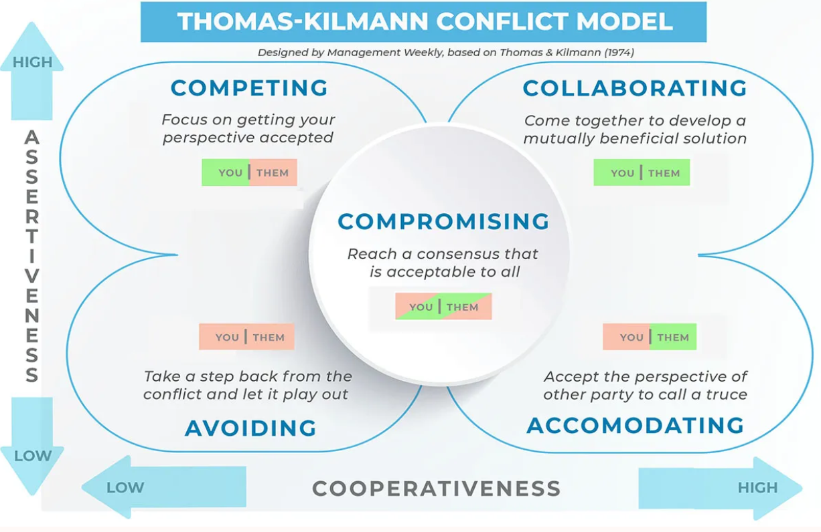

Conflict Mode Self-Assessment determines an individual’s preferred style of dealing with conflict (competing, accommodating, collaborating, avoiding, or compromising).

- Competing
Characteristics
- Assertive
- Uncooperative
- Pursues own concerns and needs sometimes at the expense of others
- It’s all about defending your position; standing your ground
- Able to effectively communicate views and persuade others
- Opposite of Accommodating

When it may be appropriate to use
- Issue is very important to you (there is a need to protect your or own self-interests)
- Little time for discussion and quick action needs to be taken (i.e. crisis)
- Problem is simple (does not require input from others)
- Culture and reward system support a win/lose environment
When it may be inappropriate to use
- Cooperation from others is important
- Complex problems
- Issue is important to others
- Maintaining good relationships with others is essential

- Accommodating
Characteristics
- Unassertive
- Cooperative
- Neglects one’s own concerns to satisfy the concerns of others
- Yields to another’s point of view
- Selfless
- The opposite of competing

When it may be appropriate to use
- Issue is more important to others than to you
- Little time for discussion
- Preserving the relationship
- Continued competing would likely damage your cause (i.e. when you are losing)
- Issue is simple (does not require input from others)
- Fostering development of subordinates (i.e. allowing them to experiment)
- Culture and reward system encourage compliance

When it may be inappropriate to use
- Complex problems
- Issue is important to you
- You have unique insight regarding the issue

- Compromising
Characteristics
- Moderately assertive
- Moderately cooperative
- Goal is to satisfy both parties
- Finding the middle ground (splitting the difference)
- Negotiating
- Between competing and accommodating
When it may be appropriate to use
- Issue is moderately important to everyone
- Little time for discussion
- Back-up to collaborating or when competing fails to be successful
- The value of maintaining the relationship is more important than the outcome
- Culture and reward system encourage quick fixes and immediate results
When it may be inappropriate to use
- Complex issues
- Issue is very important to both parties
- One or both parties are unwilling to give up something to reach middle ground

- Avoiding
Characteristics
- Unassertive
- Uncooperative
- Does not pursue concerns of other party
- Withdrawals
- Does not deal with the situation
- Opposite of Collaborating
When it may be appropriate to use
- Stress is overwhelming or to reduce tensions and regain perspective
- Low levels of trust
- Issue is not important or other issues are more pressing
- Need for more information before making a decision
- Culture and reward system does not encourage cooperation and teamwork

When it may be inappropriate to use
- Issue is important to you
- Issue needs to be resolved
- Maintaining good relationships with others is essential

- Collaborating
Characteristics
- Assertive
- Cooperative
- Works with others to find creative solutions
- Attempts to find a solution that benefits everyone
- Opposite of Avoiding
When it may be appropriate to use
- Issue is very important to everyone
- When both sets of concerns are too important to be compromised
- High levels of trust / positive culture
- Complex issue (multiple people are needed to solve the issue)
- Ample time available
- Culture and reward system encourages cooperation and teamwork
When it may be inappropriate to use
- Overwhelming stress
- Low levels of trust / negative culture
- Issue is not very important or critical
- Limited time

Activity - Discuss: what are the advantages and disadvantages of each mode (group discussion).
Share your mode with each other.

